**Overview**

General information.

Troubleshooting Zscaler in Windows

Access the Troubleshoot menu the Zscaler Client Connector App by clicking on **More.**

* **Start Packet Capture:** Captures packet, you can use this feature when reproducing an issue. To learn more, see [Using the Start Packet Capture Option](https://help.zscaler.com/client-connector/enabling-packet-capture-zscaler-client-connector).
* **Export Logs:**
* **Restart Service:** Click to restart the app. Restarting does not impact security enforcement.
* **Repair App:** If you select this option, the app will attempt to repair itself by reinstalling app drivers and services. Zscaler recommends trying this option before reporting an issue.
* **Clear Logs**: You can clear stored logs.
* **Log Mode:** You can change the mode in which Zscaler Client Connector generates logs, but the change is effective for that connection session only. At the start of the next connection session, the app returns to the default log mode set by your organization. Below is a description of each log mode.
  + - **Error:** Logs only when the app encounters an error and functionality is affected.
    - **Warn:** Logs when the app is functioning but is encountering potential issues, or logs when conditions for the Error log mode are met.
    - **Info:** Logs general app activity, or logs when conditions for the Warn log mode are met.
    - **Debug**: Logs all app activity that could assist Zscaler Support in debugging issues, or logs when conditions for the Info log mode are met.

Troubleshooting Zscaler in macOS

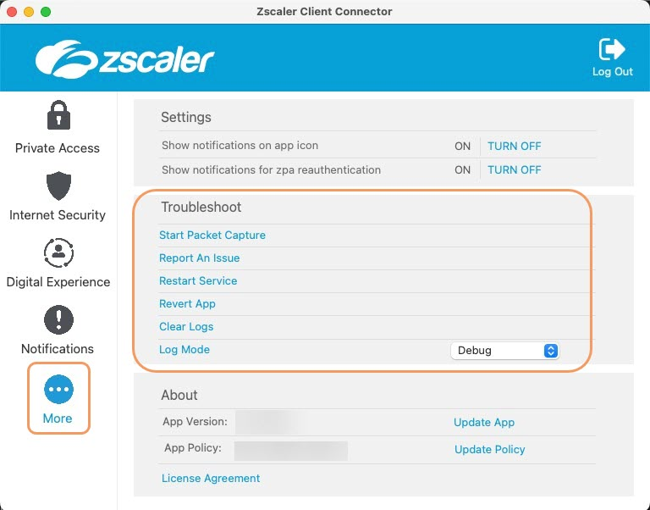Access the Troubleshoot menu the Zscaler Client Connector App by clicking on **More.**

* **Start Packet Capture:** Captures packet, you can use this feature when reproducing an issue. To learn more, see [Using the Start Packet Capture Option](https://help.zscaler.com/client-connector/enabling-packet-capture-zscaler-client-connector).
* **Export Logs:**
* **Restart Service:** You can click to restart the app. Restarting does not impact security enforcement.
* **Repair App:** If you select this option, the app will attempt to repair itself by reinstalling app drivers and services. Zscaler recommends trying this option before reporting an issue.
* **Clear Logs**: You can clear stored logs.
* **Log Mode:** You can change the mode in which Zscaler Client Connector generates logs, but the change is effective for that connection session only. At the start of the next connection session, the app returns to the default log mode set by your organization. Below is a description of each log mode.
  + - **Error:** Logs only when the app encounters an error and functionality is affected.
    - **Warn:** Logs when the app is functioning but is encountering potential issues, or logs when conditions for the Error log mode are met.
    - **Info:** Logs general app activity, or logs when conditions for the Warn log mode are met.
    - **Debug**: Logs all app activity that could assist Zscaler Support in debugging issues, or logs when conditions for the Info log mode are met.

Troubleshooting Zscaler in iOS

Access the Troubleshoot menu the Zscaler Client Connector App by clicking on **More.**

* **Start Packet Capture:** Captures packet, you can use this feature when reproducing an issue. To learn more, see [Using the Start Packet Capture Option](https://help.zscaler.com/client-connector/enabling-packet-capture-zscaler-client-connector).
* **Export Logs:**
* **Restart Service:** You can click to restart the app. Restarting does not impact security enforcement.
* **Repair App:** If you select this option, the app will attempt to repair itself by reinstalling app drivers and services. Zscaler recommends trying this option before reporting an issue.
* **Clear Logs**: You can clear stored logs.
* **Log Mode:** You can change the mode in which Zscaler Client Connector generates logs, but the change is effective for that connection session only. At the start of the next connection session, the app returns to the default log mode set by your organization. Below is a description of each log mode.
  + - **Error:** Logs only when the app encounters an error and functionality is affected.
    - **Warn:** Logs when the app is functioning but is encountering potential issues, or logs when conditions for the Error log mode are met.
    - **Info:** Logs general app activity, or logs when conditions for the Warn log mode are met.
    - **Debug**: Logs all app activity that could assist Zscaler Support in debugging issues, or logs when conditions for the Info log mode are met.